HW34

a,b,c)

i,ii,iii)Extract features from original datasets

Code:

import numpy as np  
import pandas as pd  
  
b = np.zeros((1, 42))  
file_name = 'dataset1.csv'  
a1 = pd.read_csv(file_name, header=None, usecols=[0])  
a2 = pd.read_csv(file_name, header=None, usecols=[1])  
a3 = pd.read_csv(file_name, header=None, usecols=[2])  
a4 = pd.read_csv(file_name, header=None, usecols=[3])  
a5 = pd.read_csv(file_name, header=None, usecols=[4])  
a6 = pd.read_csv(file_name, header=None, usecols=[5])  
  
b[0][0] = a1.min()  
b[0][1] = a1.max()  
b[0][2] = a1.mean()  
b[0][3] = a1.median()  
b[0][4] = a1.std()  
b[0][5] = a1.quantile(0.25)  
b[0][6] = a1.quantile(0.75)  
  
b[0][7] = a2.min()  
b[0][8] = a2.max()  
b[0][9] = a2.mean()  
b[0][10] = a2.median()  
b[0][11] = a2.std()  
b[0][12] = a2.quantile(0.25)  
b[0][13] = a2.quantile(0.75)  
  
b[0][14] = a3.min()  
b[0][15] = a3.max()  
b[0][16] = a3.mean()  
b[0][17] = a3.median()  
b[0][18] = a3.std()  
b[0][19] = a3.quantile(0.25)  
b[0][20] = a3.quantile(0.75)  
  
b[0][21] = a4.min()  
b[0][22] = a4.max()  
b[0][23] = a4.mean()  
b[0][24] = a4.median()  
b[0][25] = a4.std()  
b[0][26] = a4.quantile(0.25)  
b[0][27] = a4.quantile(0.75)  
  
b[0][28] = a5.min()  
b[0][29] = a5.max()  
b[0][30] = a5.mean()  
b[0][31] = a5.median()  
b[0][32] = a5.std()  
b[0][33] = a5.quantile(0.25)  
b[0][34] = a5.quantile(0.75)  
  
b[0][35] = a6.min()  
b[0][36] = a6.max()  
b[0][37] = a6.mean()  
b[0][38] = a6.median()  
b[0][39] = a6.std()  
b[0][40] = a6.quantile(0.25)  
b[0][41] = a6.quantile(0.75)  
  
print(b)  
  
writer = pd.ExcelWriter('newdata.xlsx', index=False)  
df1 = pd.DataFrame(data=b)  
df1.to_excel(writer, 'Sheet1')  
writer.save()  
writer.close()

result:

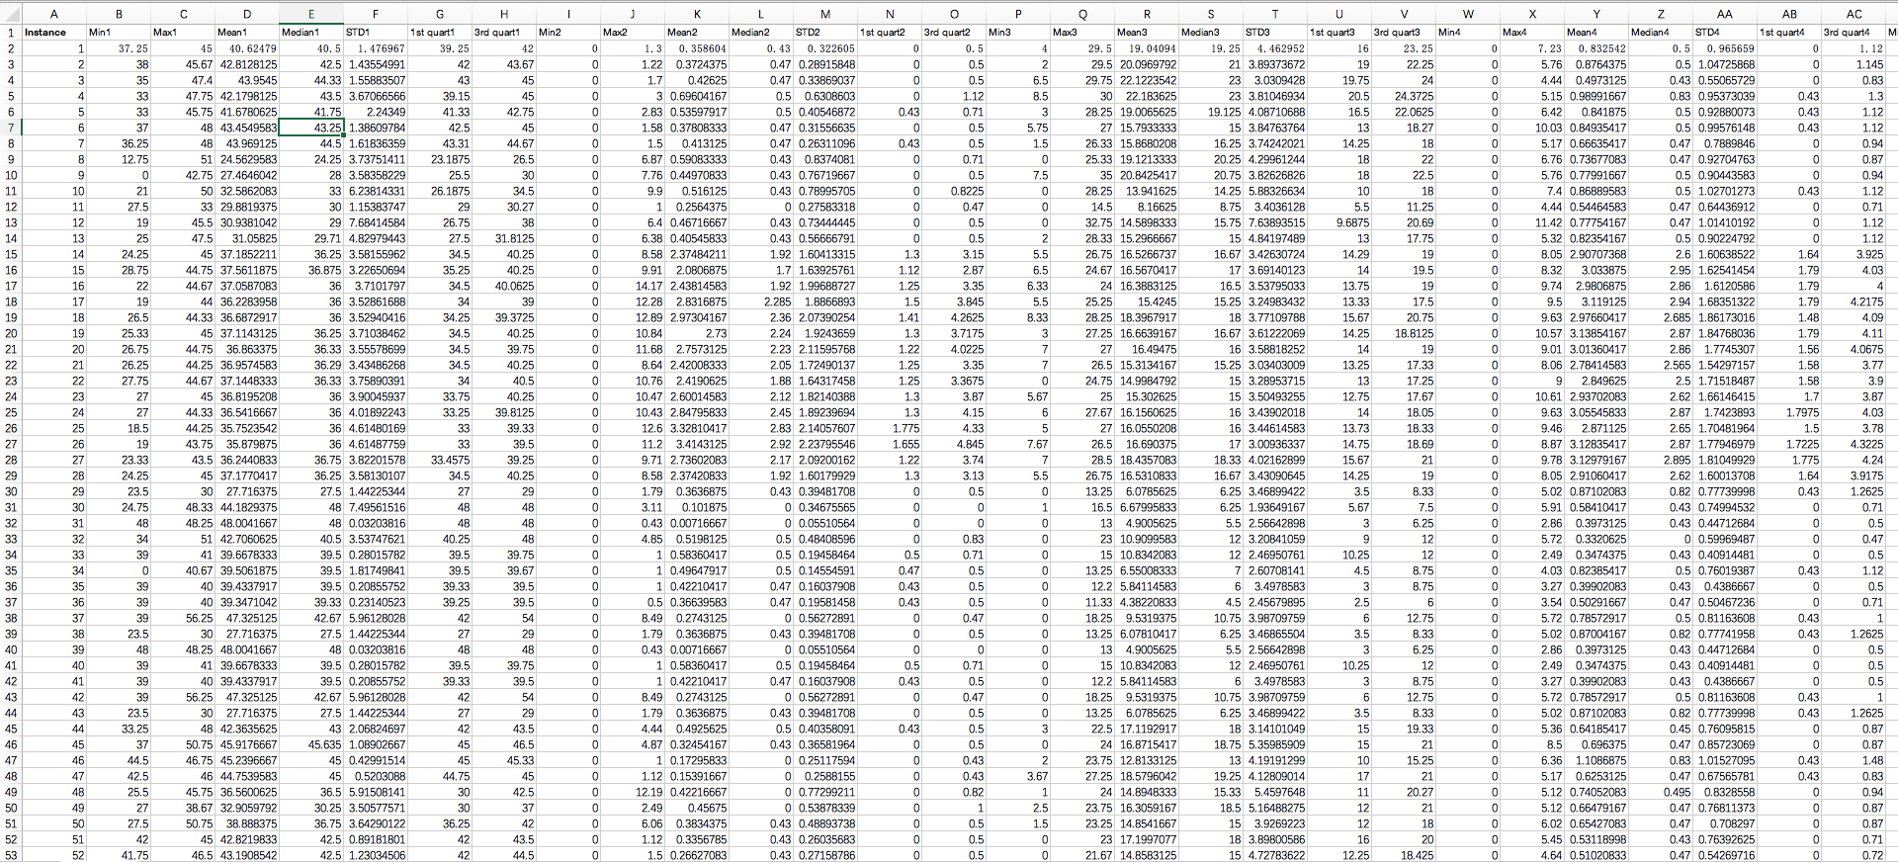

d)Show extracted features

i)I choose min, max, mean as most important features

code:

import numpy as np  
import matplotlib.pyplot as plt  
import pandas as pd  
from pandas.tools.plotting import scatter_matrix  
  
file_name1 = 'trainingdata1.csv'  
file_name2 = 'label.csv'  
a = pd.read_csv(file_name1, header=0)  
b = pd.read_csv(file_name2, header=0)  
bb = np.squeeze(b)  
df = pd.DataFrame(a)  
print(df)  
g = scatter_matrix(df, alpha=1, c=np.squeeze(b), figsize=[10, 10], marker='.')  
plt.savefig('scatter_plot_1.png')  
plt.show()

result:

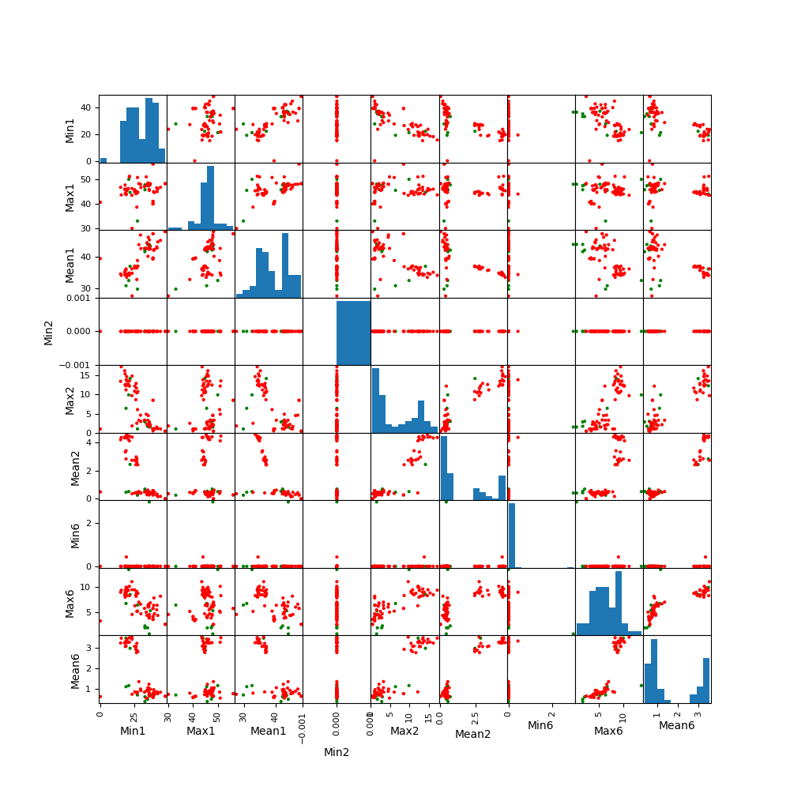

ii)

code:

import numpy as np  
import matplotlib.pyplot as plt  
import pandas as pd  
from pandas.tools.plotting import scatter_matrix  
  
file_name1 = '2_splite.csv'  
label = ['label']  
cols_except = ['6', '7', '8', '9', '10', '11', '12', '13', '14', 'label']  
  
a = pd.read_csv(file_name1, usecols=lambda x: x not in cols_except, header=0)  
b = pd.read_csv(file_name1, usecols=label, header=0)  
  
bb = np.squeeze(b)  
  
df = pd.DataFrame(a)  
  
g = scatter_matrix(df, alpha=1, c=np.squeeze(b), figsize=[10, 10], marker='.')  
plt.savefig('scatter_plot_2.png')  
plt.show()

result:

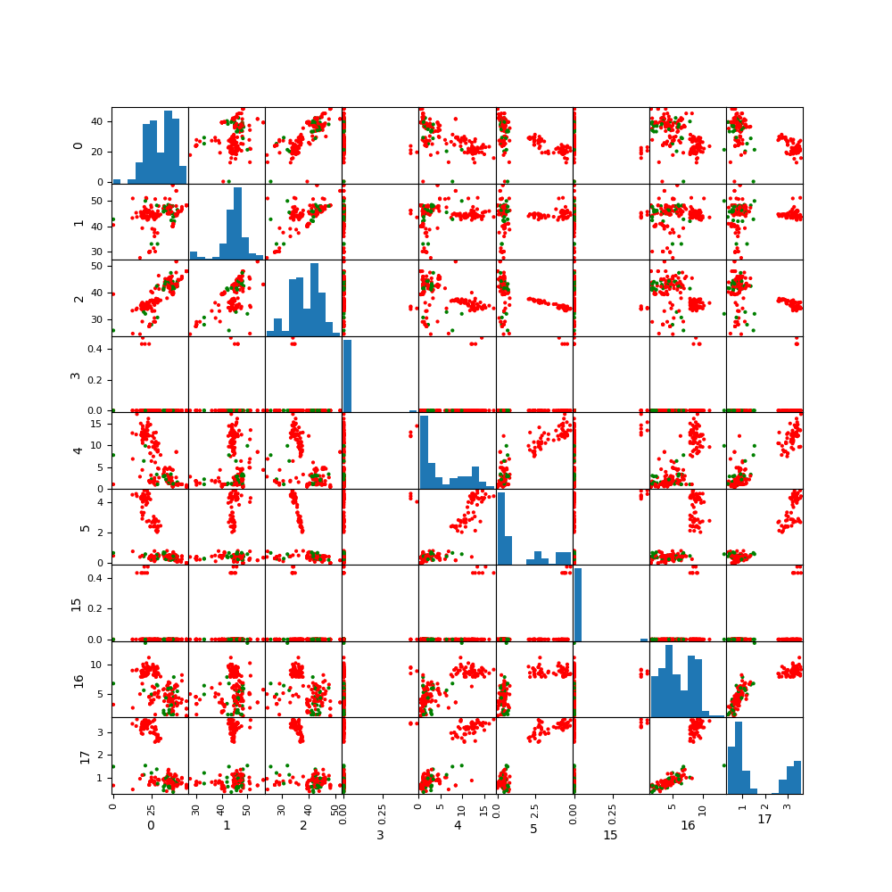

There is no considerable difference in the results with those of 1(d)i.

iii,iv,v,vi,vii)

Code:

(1)split data: use l to decide how many data does one set have

1. import pandas as pd  
   import os  
     
     
   def data_splite(foldername, l, SaveFile_Path):  
    folder_name = foldername  
    Folder_Path = r'/Users/yqh/Desktop/' + folder_name  
    SaveFile_Path = SaveFile_Path  
    SaveFile_Name = folder_name  
     
    os.chdir(Folder_Path)  
    file_list = os.listdir()  
     
    l = l  
    for i in range(0, len(file_list)):  
     
    filename = Folder_Path + '/' + file_list[i]  
    j = 480 // l  
    # if 480 % l == 0:  
    # j = (480 // l) + 1  
    # else:  
    # j = (480 // l) + 2  
     
    data = pd.read_csv(filename, chunksize=l)  
    k = 1  
    for chunk in data:  
    if k <= j:  
    chunk.to_csv(SaveFile_Path + '/' + SaveFile_Name + '_' + file_list[i] + str(k) + '.csv',  
    encoding="utf_8_sig",  
    index=False, header=False, mode='a+')  
    k += 1  
     
     
   l = 480  
   SaveFile_Path = r'/Users/yqh/Desktop/1'  
   folder_list = ['bending1', 'bending2', 'cycling', 'lying', 'sitting', 'walking', 'standing']  
   for i in range(0, len(folder_list)):  
    foldername = folder_list[i]  
    data_splite(foldername, l, SaveFile_Path)

(2)Extract data features, and label different kind of data

Code:

import pandas as pd  
import os  
import numpy as np  
  
  
def calculate(filename):  
 b = np.zeros((1, 42))  
 file_name = filename  
 a1 = pd.read_csv(file_name, header=1, usecols=[0], engine='python')  
 a2 = pd.read_csv(file_name, header=1, usecols=[1], engine='python')  
 a3 = pd.read_csv(file_name, header=1, usecols=[2], engine='python')  
 a4 = pd.read_csv(file_name, header=1, usecols=[3], engine='python')  
 a5 = pd.read_csv(file_name, header=1, usecols=[4], engine='python')  
 a6 = pd.read_csv(file_name, header=1, usecols=[5], engine='python')  
  
 b[0][0] = a1.min()  
 b[0][1] = a1.max()  
 b[0][2] = a1.mean()  
 b[0][3] = a1.median()  
 b[0][4] = a1.std()  
 b[0][5] = a1.quantile(0.25)  
 b[0][6] = a1.quantile(0.75)  
  
 b[0][7] = a2.min()  
 b[0][8] = a2.max()  
 b[0][9] = a2.mean()  
 b[0][10] = a2.median()  
 b[0][11] = a2.std()  
 b[0][12] = a2.quantile(0.25)  
 b[0][13] = a2.quantile(0.75)  
  
 b[0][14] = a3.min()  
 b[0][15] = a3.max()  
 b[0][16] = a3.mean()  
 b[0][17] = a3.median()  
 b[0][18] = a3.std()  
 b[0][19] = a3.quantile(0.25)  
 b[0][20] = a3.quantile(0.75)  
  
 b[0][21] = a4.min()  
 b[0][22] = a4.max()  
 b[0][23] = a4.mean()  
 b[0][24] = a4.median()  
 b[0][25] = a4.std()  
 b[0][26] = a4.quantile(0.25)  
 b[0][27] = a4.quantile(0.75)  
  
 b[0][28] = a5.min()  
 b[0][29] = a5.max()  
 b[0][30] = a5.mean()  
 b[0][31] = a5.median()  
 b[0][32] = a5.std()  
 b[0][33] = a5.quantile(0.25)  
 b[0][34] = a5.quantile(0.75)  
  
 b[0][35] = a6.min()  
 b[0][36] = a6.max()  
 b[0][37] = a6.mean()  
 b[0][38] = a6.median()  
 b[0][39] = a6.std()  
 b[0][40] = a6.quantile(0.25)  
 b[0][41] = a6.quantile(0.75)  
  
 return b  
  
  
def extra(j):  
 # j = 5  
 Folder_Path = r"/Users/yqh/Desktop/" + str(j) + r"/testing"  
 # SaveFile_Path = '/Users/yqh/Desktop/' + str(j) + '/'  
 SaveFile_Path = r'/Users/yqh/Desktop'  
 SaveFile_Name = str(j) + r"_testing.csv"  
  
 os.chdir(Folder_Path)  
  
 file_list = os.listdir()  
  
 filename = Folder_Path + '/' + file_list[0]  
 if file_list[0] != '.DS_Store':  
 b = calculate(filename)  
 df = pd.DataFrame(data=b)  
 if "bending" in filename:  
 df['label'] = 'g'  
 else:  
 df['label'] = 'r'  
 df.to_csv(SaveFile_Path + '/' + SaveFile_Name, encoding="utf_8_sig", index=False)  
 else:  
 print('first file is not valid')  
  
 for i in range(1, len(file_list)):  
 filename = Folder_Path + '/' + file_list[i]  
 if file_list[i] != '.DS_Store':  
 b = calculate(filename)  
 df = pd.DataFrame(data=b)  
 if "bending" in filename:  
 df['label'] = 'g'  
 else:  
 df['label'] = 'r'  
 df.to_csv(SaveFile_Path + '/' + SaveFile_Name, encoding="utf_8_sig", index=False, header=False, mode='a+')  
 else:  
 continue  
  
  
for j in range(20, 21, 1):  
 extra(j)

**(3)Feature selection and logistic regression**

**Code:**

from sklearn.feature_selection import RFECV  
from sklearn.linear_model import LogisticRegression  
import pandas as pd  
import matplotlib.pyplot as plt  
  
j = 15  
Folder_Path = r"/Users/yqh/Desktop/" + str(j)  
file_name = Folder_Path + '/' + str(j) + r"_testing.csv"  
  
X = pd.read_csv(file_name, header=None, usecols=range(0, 41))  
y = pd.read_csv(file_name, header=None, usecols=[42])  
  
LR = LogisticRegression()  
rfecv = RFECV(estimator=LR, step=1, cv=5, scoring='accuracy')  
rfecv = rfecv.fit(X, y)  
# print(rfecv.support_)  
# print(rfecv.ranking_)  
print("Optimal number of features : %d" % rfecv.n_features_)  
  
plt.figure()  
plt.xlabel("Number of features selected")  
plt.ylabel("Cross validation score (nb of correct classifications)")  
plt.plot(range(1, len(rfecv.grid_scores_) + 1), rfecv.grid_scores_)  
plt.show()

**result:**



**(e)Use L1 penalized logistic regression**

**Code:**

from sklearn.feature_selection import RFECV  
from sklearn.linear_model import LogisticRegression  
import pandas as pd  
import matplotlib.pyplot as plt  
  
j = 1  
Folder_Path = r"/Users/yqh/Desktop/" + str(j)  
file_name = Folder_Path + '/' + str(j) + r"_training.csv"  
  
X = pd.read_csv(file_name, header=None, usecols=range(0, 41))  
y = pd.read_csv(file_name, header=None, usecols=[42])  
  
LR = LogisticRegression(penalty='l1')  
rfecv = RFECV(estimator=LR, step=1, cv=5, scoring='accuracy')  
rfecv = rfecv.fit(X, y)  
# print(rfecv.support_)  
# print(rfecv.ranking_)  
print("Optimal number of features : %d" % rfecv.n_features_)  
  
plt.figure()  
plt.xlabel("Number of features selected")  
plt.ylabel("Cross validation score (nb of correct classifications)")  
plt.title('l = ' + str(j))  
plt.plot(range(1, len(rfecv.grid_scores_) + 1), rfecv.grid_scores_)  
plt.show()

**result:**

** **

**L1 penalized logistic regression performs better.**